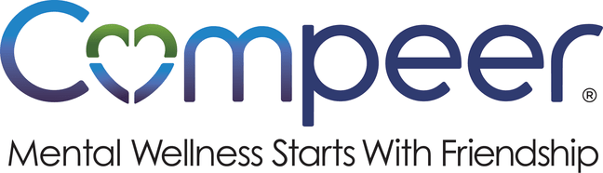

External Guide: Hosting a Third-Party Fundraiser for Compeer

Host a Fundraiser. Build Connection. Make an Impact.
When you host a fundraiser for Compeer, you’re doing more than raising dollars: you’re helping spark friendships, strengthen mental wellness, and remind people they’re not alone. That’s powerful.
Whether your idea is something simple or something big and bold, we’re so glad you’re here.

What Is a Third-Party Fundraiser?
A Third-Party Fundraiser is an event or activity that you plan and host, with proceeds supporting Compeer’s mission. Think of it as your opportunity to rally your people around connection, compassion, and community impact.
Activities may be public-facing or internal to your workplace.

Fundraiser Ideas to Spark Inspiration!
There’s no “right” way to fundraise, just your way. Here are a few ideas to get you started:
- Office dress-down or casual days
- Friendly workplace competitions or challenges
- Payroll giving or team campaigns
- Matching gift drives
- Percentage-of-sales or “giveback” nights
- Athletic tournaments (golf, pickleball, bowling, you name it!)
- Raffles or themed events

Have a different idea? Even better! We love your creativity. Let’s build something meaningful together.

How We Support You
We’re here to make this feel easy, breezy, collaborative, and aligned with our shared mission.
Our team can provide:
- Approved logos and brand guidelines
- A clear, inspiring overview of Compeer’s impact
- Optional promotion through social media or newsletters to highlight your impact
- Staff support or attendance (when available)
- Arrangements for Compeer staff and / or client(s) to share their experience(s) upon host request.
- Compeer literature and / or related materials

What You’ll Lead
As the host, you take the lead in bringing your fundraiser to life. That includes:
- Planning and managing your event or campaign
- Handling logistics, pricing, and transactions
- Clearly communicating how funds will be raised
- Using Compeer’s name and logo with approval
- Submitting funds within the agreed-upon timeline
- A check presentation and / or public announcement of donation (at your discretion)

Think of us as your partner and cheering section: you’re in the driver’s seat, but we’re right alongside you.

Is This a Good Fit? Quick Checklist ✅
Your fundraiser likely qualifies as a Third-Party Fundraiser if:
☐ The activity is initiated and hosted by an external business, workplace, or organization
☐ The activity is either public facing or internal/employee-only
☐ Compeer does not manage logistics, sales, pricing, or transactions
☐ Compeer Staff involvement is limited / optional
☐ Compeer’s name, logo, and mission will be represented accurately and with approval
☐ There is a clear plan for how and when donated funds will be delivered
If you’re unsure, don’t worry! We’ll figure it out together.

The Simple Agreement Process
Before you get started, we’ll ask you to complete a quick agreement form.
This helps:
- Set clear expectations
- Align on branding and messaging
- Make sure everything runs smoothly

Once it’s signed, you’re officially part of the Compeer fundraising family!

Ready to Get Started? Let’s Do This.
We’d love to hear your ideas and help you bring them to life.
📧development@compeerbuffalo.org
Together, we can turn great ideas into real connection, real impact, and real friendship—right here in our community. Thank you for being a mental health champion!

